Multi dimensional visua

**Multidimensional visualization** is a powerful technique for representing complex data with multiple dimensions in an intuitive and informative way. Let’s delve into this fascinating topic.

1. **Scatter Matrix**:
   * The scatter matrix is an excellent plot for understanding relationships (usually linear) between multiple variables in a dataset.
   * When you observe a linear graph between two or more variables, it indicates a high correlation between those features (either positive or negative).
   * Here’s an example of a scatter matrix using a diabetes patients dataset:

!Scatter Matrix

* + In this plot, each cell represents the scatter plot between two features. The diagonal cells show histograms for individual features, while the off-diagonal cells display scatter plots.
  + [By analyzing the scatter matrix, we can gain insights into how different features relate to each other1](https://www.analyticsvidhya.com/blog/2022/09/data-visualization-guide-for-multi-dimensional-data/).

1. **Effective Strategies**:
   * When visualizing multi-dimensional data, consider the following strategies:
     + **Layered Grammar of Graphics**: Describe and understand each component involved in visualization (data, aesthetics, scale, objects, etc.).
     + **Structured Data**: Visualize structured data (ranging from 1-D up to 6-D) effectively.
     + [**Unstructured Data**: Explore unstructured data, including text, images, and audio2](https://medium.com/swlh/effective-visualization-of-multi-dimensional-data-a-hands-on-approach-b48f36a56ee8)..

Situations used:

1. **Exploratory Data Analysis (EDA)**:
   * During the initial stages of data exploration, multidimensional visualization helps identify patterns, correlations, and outliers.
   * EDA often involves examining relationships between multiple features simultaneously. Scatter plots, parallel coordinates, and scatter matrices are commonly used techniques.
2. **Feature Selection and Engineering**:
   * When dealing with high-dimensional datasets, selecting relevant features is crucial.
   * Multidimensional visualization aids in understanding feature distributions, identifying redundant or irrelevant features, and discovering new ones.
3. **Clustering and Classification**:
   * Visualizing data in higher dimensions assists in clustering similar data points.
   * Techniques like t-SNE (t-Distributed Stochastic Neighbor Embedding) and UMAP (Uniform Manifold Approximation and Projection) reduce dimensions while preserving neighborhood relationships.

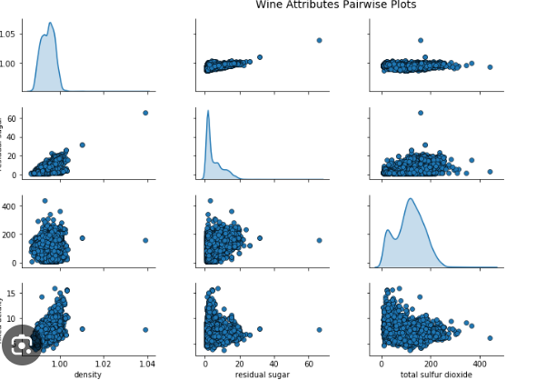

2.multi-variate visualization:

1. **nivariate Analysis**:
   * **Univariate analysis** focuses on visualizing **one variable at a time**.
   * It helps us understand the distribution of a single variable within a dataset.
   * [Examples include histograms for numerical variables, bar charts for categorical data, and pie charts for percentage breakdowns1](https://www.geeksforgeeks.org/what-is-univariate-bivariate-multivariate-analysis-in-data-visualisation/).
2. **Bivariate Analysis**:
   * **Bivariate analysis** involves analyzing **two variables simultaneously**.
   * It explores the concept of the relationship between two variables, whether there exists an association, and the strength of this association, or whether there are differences between two variables and the significance of these differences.
   * The main three types of bivariate analysis are:
     + **Categorical vs. Numerical**: For instance, comparing department-wise employee service length using a bar chart.
     + **Numerical vs. Numerical**: Scatter plots reveal patterns between age and length of service.
     + [**Categorical vs. Categorical**: Count plots show status changes over years1](https://www.geeksforgeeks.org/what-is-univariate-bivariate-multivariate-analysis-in-data-visualisation/).
3. **Multivariate Analysis**:
   * **Multivariate analysis** extends bivariate analysis to **multiple variables**.
   * It examines correlations and patterns across several dimensions simultaneously.
   * Use cases for multivariate analysis include:
     + **Exploring Complex Data**: When dealing with high-dimensional data (e.g., genomics, medical imaging).
     + **Feature Selection**: Identifying relevant features while considering interactions.

Situations used:

In statistics, multivariate analysis of variance (MANOVA) is a procedure for comparing multivariate sample means. As a multivariate procedure, it is used when there are two or more dependent variables, and is often followed by significance tests involving individual dependent variables separately

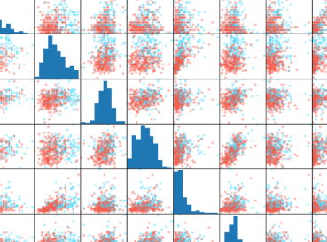

3.tree visualization:

1. **Binary Search Tree Visualization**:
   * You can interactively visualize binary search trees (BSTs) using the tool provided by the **University of San Francisco**. It allows you to see how BSTs evolve during various operations such as insertion, deletion, and searching. [Check it out](https://www.cs.usfca.edu/~galles/visualization/BST.html)[here1](https://www.cs.usfca.edu/~galles/visualization/BST.html).
2. **B-Tree Visualization**:
   * B-trees are another type of tree structure commonly used in databases and file systems. The University of San Francisco offers an interactive visualization for B-trees. You can explore different B-tree configurations, including maximum degrees (e.g., 3, 4, 5, 6, or 7), and even observe pre-emptive split and merge operations

Situations used :

1. **ost in the Enchanted Forest**:
   * Imagine wandering through an ancient, mystical forest. The trees whisper secrets, and the air is thick with magic. You stumble upon a forked path. To the left, a narrow trail leads deeper into the forest, where mythical creatures might dwell. To the right, a sun-dappled glade invites you to rest. Which path do you choose, and what awaits you there?
2. **The Forgotten Diary**:
   * You discover an old, leather-bound diary hidden in the attic. Its pages are yellowed, and the ink has faded, but the words tell a captivating tale. As you read, you become entangled in the life of its mysterious author

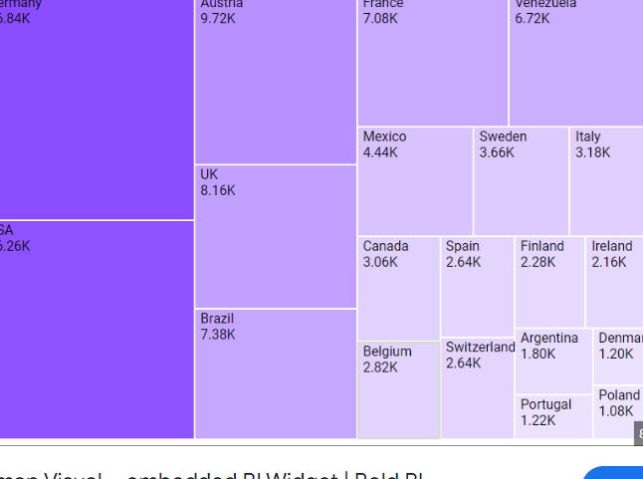

4.Temporal visualization:

Temporal Visualization Explained Temporal visualization is the art of representing data that changes over time. It helps us understand trends, patterns, and relationships within the data across different timeframes. Imagine it as a window into the flow of information, allowing us to see how things evolve. Here are some reasons why temporal visualization is important:

● Identifying Trends: It helps us spot trends and patterns in data over time. For example, a line graph showing stock prices over a year can reveal upward or downward trends.

● Making Comparisons: We can compare data points across different time periods. This can be useful for analyzing changes in sales figures or website traffic over months or years.

● Understanding Relationships: Temporal visualizations can help us see how different variables relate to each other over time. For instance, a scatter plot with time on the x-axis can show how temperature fluctuations affect ice cream sales

Line chart:

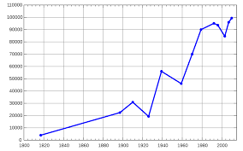

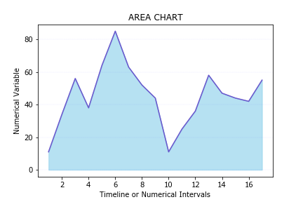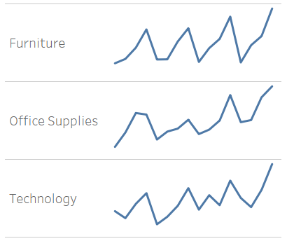

5.Textual visualization:

1. **Word Clouds**:
   * Word clouds display words from a text, with the size of each word proportional to its frequency. Prominent terms stand out, making it easy to identify key themes or topics. These are often used for visualizing customer feedback, social media posts, or any text data where word frequency matters.
2. **Tag Clouds**:
   * Similar to word clouds, tag clouds emphasize frequently occurring terms. They are commonly used in web applications to visualize popular tags or keywords associated with content.
3. **Slope Charts**:
   * Slope charts show changes in values between two points. They are useful for comparing trends over time or across different categories. While not exclusively for text data, they can be adapted to visualize textual information.
4. **Sankey Charts**:
   * Sankey charts depict flows or relationships between entities. In the context of text data, they can represent connections between topics, sentiments, or other attributes.

**Why do we need text visualization?**

* **Summarize Large Amounts of Text**: Automatically highlighting key terms in a series of texts and categorizing text by topic or sentiment saves hours of reading time.
* **Make Text Data Understandable**: Our brains process visual data much faster than plain text. Text visualization simplifies complex data and effectively communicates ideas to team managers.
* **Find Insights in Qualitative Data**: Customer feedback contains valuable insights. Text visualization helps identify important features, products, and topics.

Tabular data

